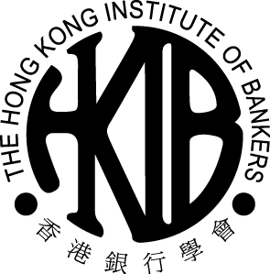 | THE HONG KONG INSTITUTE OF BANKERS  Updating Form for Change of Information on Membership Record  會員資料更新表

- Please complete all section in BLOCK CAPITAL LETTERS.
請用英文正楷填寫表格。
- Please return the completed form to the Hong Kong Institute of Bankers, 3/F Guangdong Investment Tower, 148 Connaught Road Central, Sheung Wan, Hong Kong by fax/mail
表格填妥後請傳真或郵寄至本學會 — 香港上環干諾道中一百四十八號，粵海投資大廈三樓。

* Please delete as appropriate 請刪去不合適部份

Section A: Basic Details 基本資料

English Name英文姓名: Mr先生 / Ms女士 _________________________ Chinese Name中文姓名: ________________

HKID Card/Passport no.香港身份證/護照號碼: Membership no.會員編號: _______________

Section B: Please only fill in the details that you wish to amend 請塡寫只須更改的資料

English Name英文姓名: Mr先生 / Ms女士 _________________________ Chinese Name中文姓名: ________________

Name of Employer僱主:

Department 部門: _____________________________________ Job Title職位: _______________________________

Correspondence Address通訊地址: ○ Home住宅 ○ Office公司

Telephone no.電話號碼: ____________________________ (Home住宅) ____________________________ (Office公司)

Fax no.傳真號碼:_______________________________ (Home住宅) _______________________________ (Office公司)

Mobile no.手提電話號碼: __________________________ (Hong Kong香港) __________________________ (China中國)

E-mail電子郵件: (1)

E-mail電子郵件: (2)

Name of Institute學府名稱:

Highest Academic Qualifications最高學歷:

Professional Qualifications專業資格:

Others (Pls specify) 其他(請列明) _______________________________________________________________________

I confirm all details given above are correct.本人確定以上填報之資料均屬真確。

Signature簽名 Date日期

The information provided will be used for updating the membership record with the Institute. The collection of HKID card number (or other personal identifiers) is for the identification and the advancement of members’ interest.

For Office Use Only學會專用
Received on: | Post Code:
Amended on: | Amended by:
Checked on: | Checked by:

